Exploration completed：

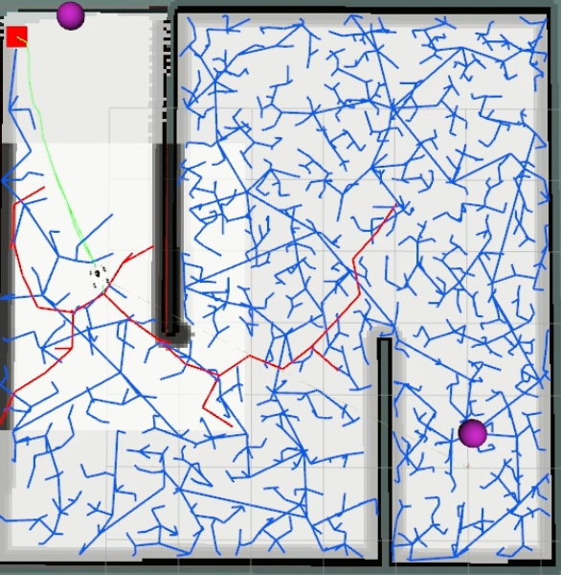

Defects：No

Rate of coverage：100%